Technical Documentation Report: CPU Scheduling Algorithms Simulation

1. Introduction
Overview of CPU Scheduling CPU scheduling is the orchestrating mechanism at the heart of modern multitasking operating systems. In an environment where multiple processes compete for a limited number of processor cores, the scheduler determines the order and duration of execution for each task. The primary goal is to maximize CPU utilization and throughput while minimizing waiting time, turnaround time, and response time. From an architectural perspective, the scheduler acts as a resource manager that balances the needs of interactive user applications against high-throughput background tasks.
Purpose of the Case Study This case study serves as a rigorous practical implementation of fundamental scheduling algorithms. By transitioning from theoretical mathematical models to a functional Python-based simulation, we can observe the behavioral nuances of different scheduling strategies. This project bridges the gap between abstract process management concepts and tangible system performance metrics.
Program Objectives The simulation software is designed to meet several critical technical objectives:
- Dynamic Input Handling: The system supports a minimum of 3 processes, accepting dynamic Process IDs, Arrival Times, Burst Times, and Priority values.
- Algorithmic Fidelity: Accurate simulation of both preemptive and non-preemptive logic, including complex hybrid models like Priority with Round Robin.
- Visual Analytics: Generation of text-based and graphical Gantt charts to visualize execution timelines and the calculation of key performance indicators (WT and TAT).
- Architectural Integrity: Utilization of modular programming practices to ensure the simulation engine remains decoupled from the visualization layer.
--------------------------------------------------------------------------------

2. Simulation Mechanism and Algorithm Analysis

2.1. First-Come, First-Served (FCFS)
- Mechanism: Processes are dispatched according to their arrival time. The first process to enter the ready queue is the first to be allocated the CPU.
- Status: Non-preemptive.
- Advantages: Simple logic; low computational overhead; eliminates the possibility of starvation.
- Limitations: Highly susceptible to the "convoy effect," where short processes are forced to wait behind a long-running process, inflating average waiting times.
Architect’s Note: While FCFS is rarely used as a standalone scheduler in modern general-purpose OSs due to poor responsiveness, it remains a critical component of multi-level queues where simple FIFO order is required for specific task tiers.

Test Case 1
Process ID | Arrival Time | Burst Time
P1 | 0 | 5
P2 | 1 | 3
P3 | 2 | 8
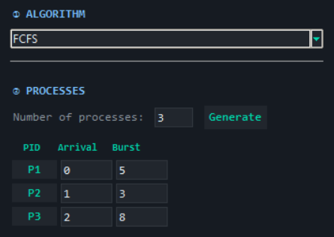
Gantt Chart: [P1 | 0-5][P2 | 5-8][P3 | 8-16]
Process | Waiting Time | Turnaround Time
P1 | 0 | 5
P2 | 4 | 7
P3 | 6 | 14
Average | 3.33 | 8.67

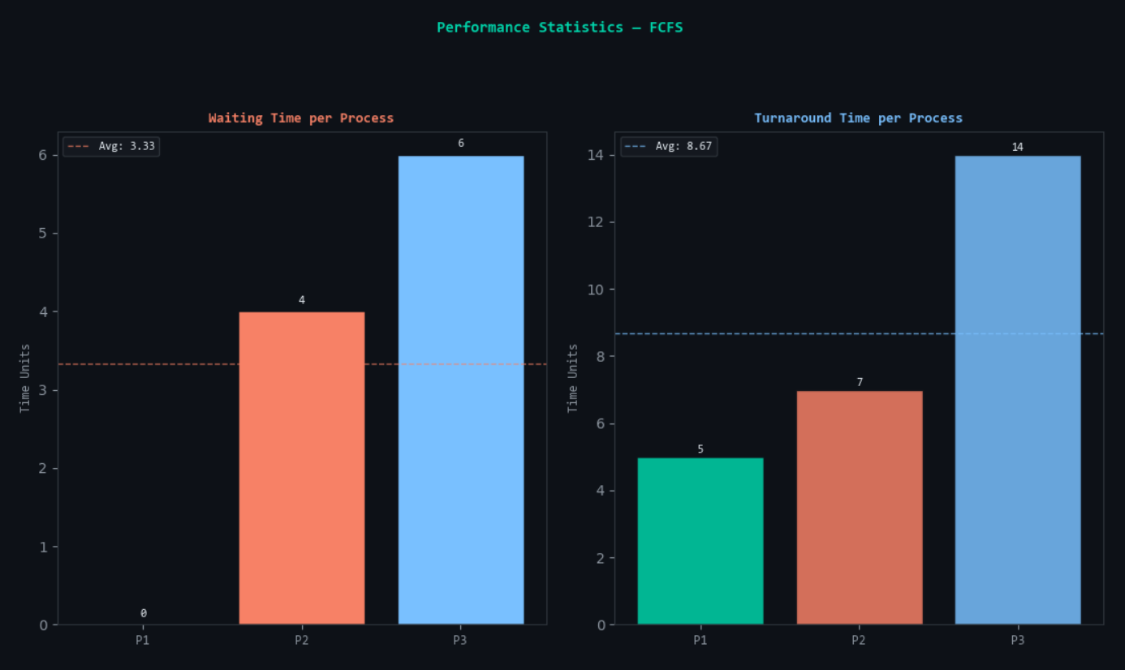

Test Case 2
Process ID | Arrival Time | Burst Time
P1 | 0 | 2
P2 | 2 | 1
P3 | 5 | 4
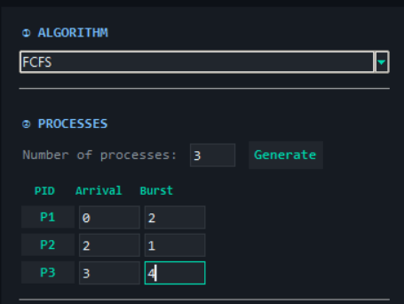
Gantt Chart: [P1 | 0-2][P2 | 2-3][IDLE | 3-5][P3 | 5-9]
Process | Waiting Time | Turnaround Time
P1 | 0 | 2
P2 | 0 | 1
P3 | 0 | 4
Average | 0.00 | 2.33
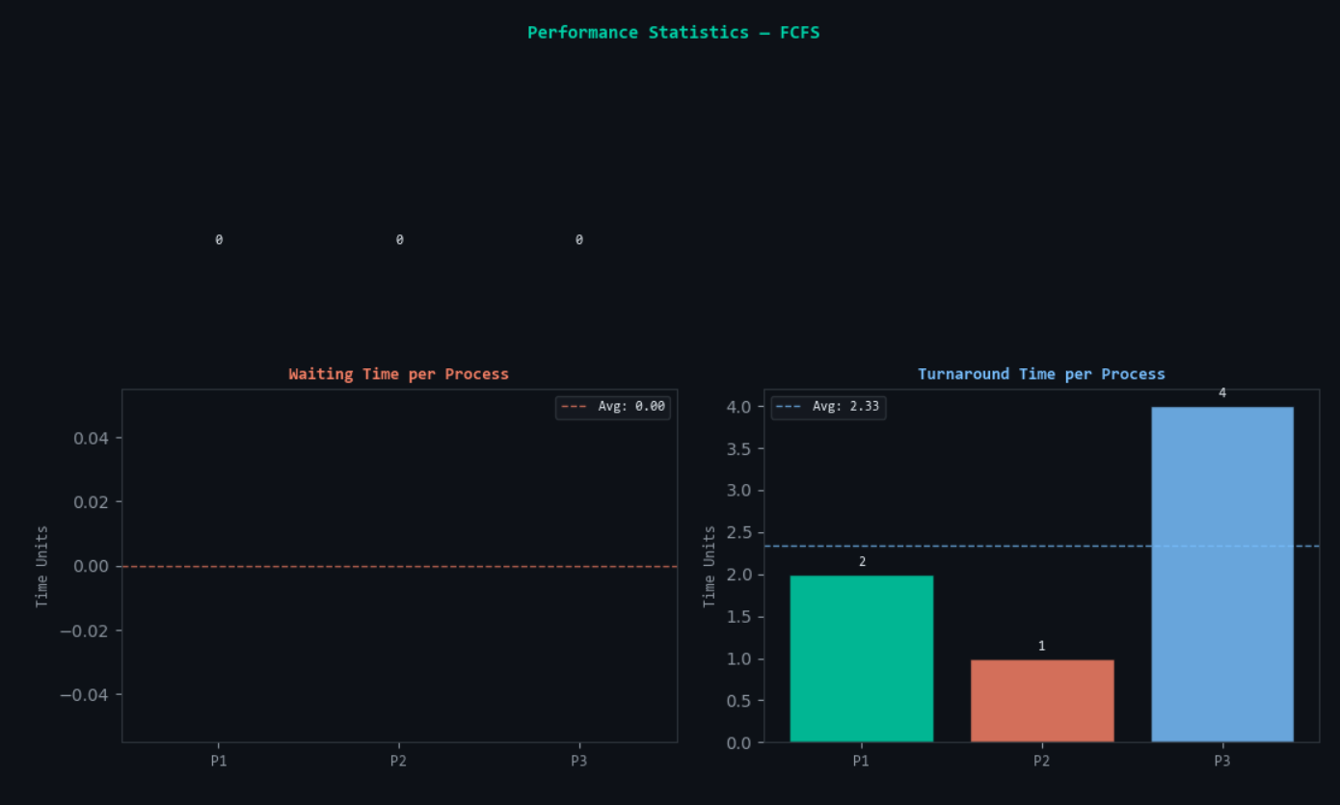
--------------------------------------------------------------------------------

2.2. Shortest Job First (SJF) – Non-preemptive
- Mechanism: The scheduler selects the process in the ready queue with the smallest burst time. Once started, the process runs to completion.
- Status: Non-preemptive.
- Advantages: Minimizes average waiting time for a fixed set of processes.
- Limitations: Requires prior knowledge of burst times (often impossible to predict); long processes may suffer from starvation.
Architect’s Note: The implementation requires a decision-making loop at every process completion point to re-scan the ready queue. This introduces a slight O(n \log n) overhead for sorting/selection but yields superior throughput.

Test Case 1
Process ID | Arrival Time | Burst Time
P1 | 0 | 7
P2 | 2 | 4
P3 | 4 | 1
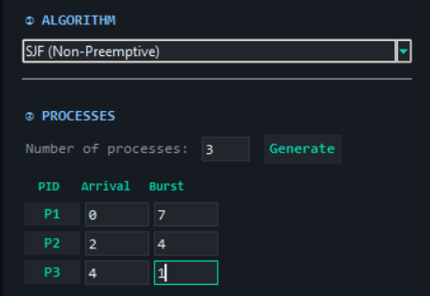
Gantt Chart: [P1 | 0-7][P3 | 7-8][P2 | 8-12]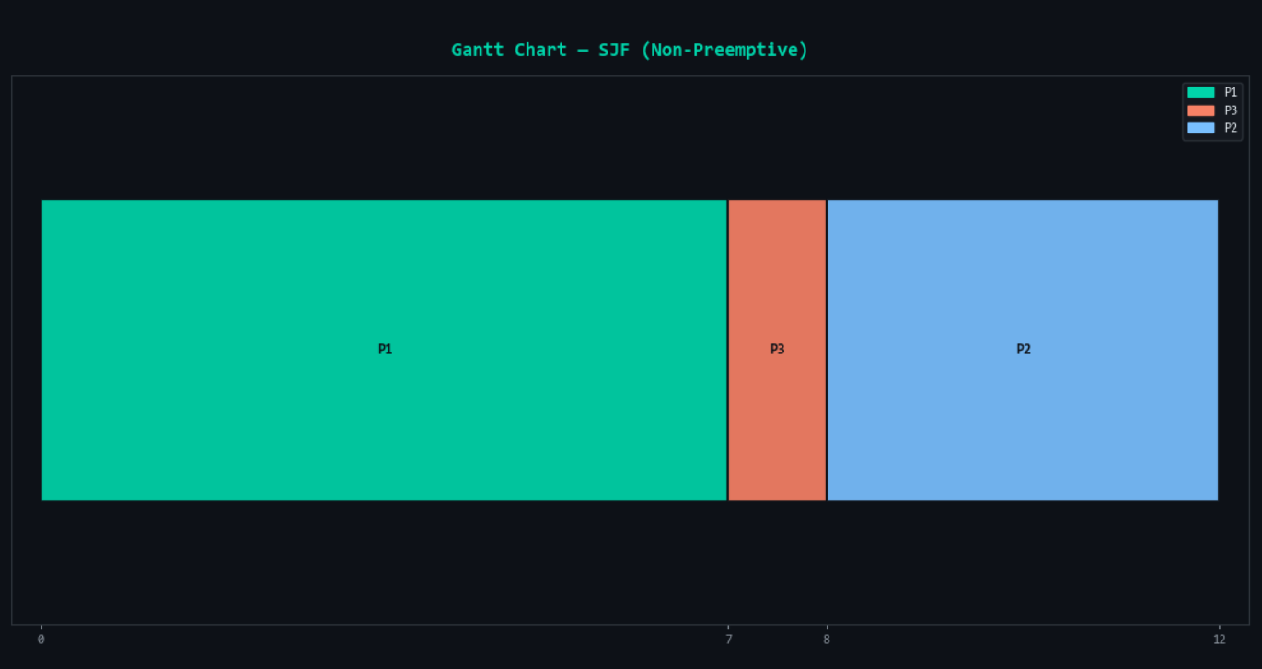
Process | Waiting Time | Turnaround Time
P1 | 0 | 7
P2 | 6 | 10
P3 | 3 | 4
Average | 3.00 | 7.00

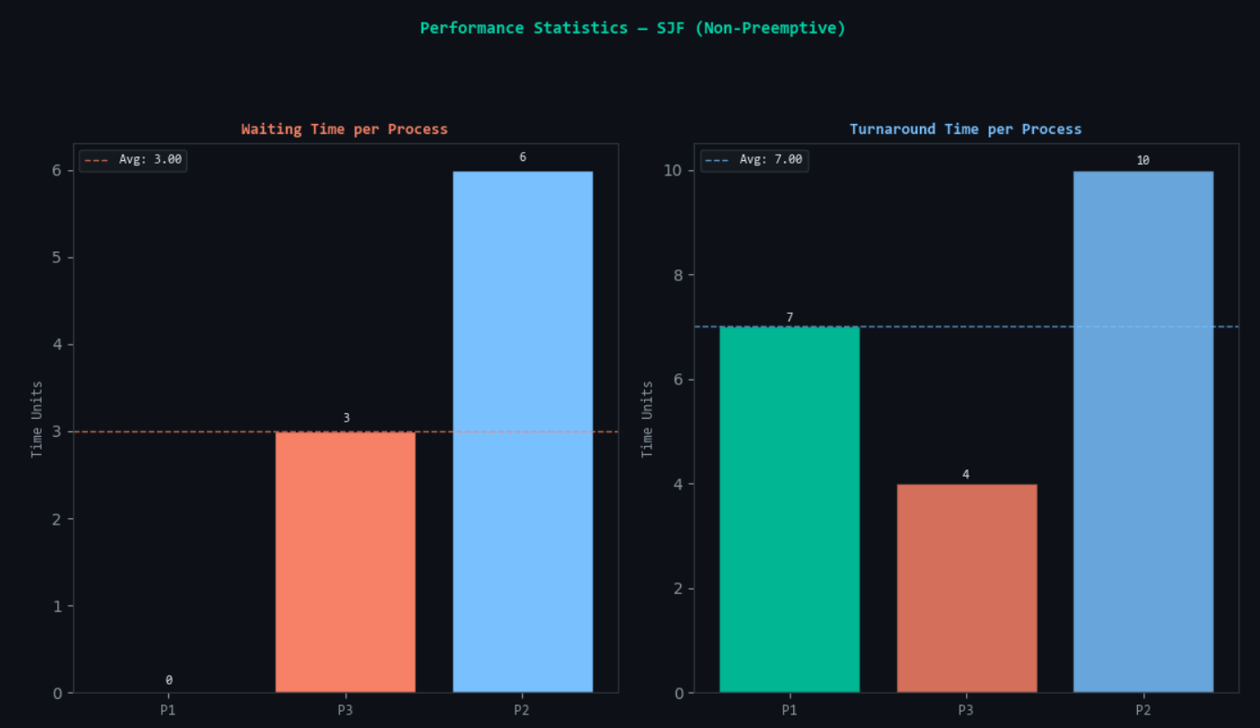

Test Case 2
Process ID | Arrival Time | Burst Time
P1 | 0 | 6
P2 | 1 | 2
P3 | 2 | 3
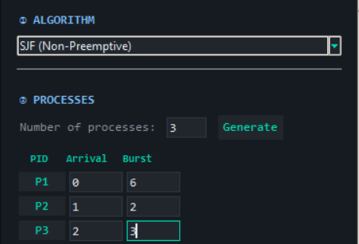
Gantt Chart: [P1 | 0-6][P2 | 6-8][P3 | 8-11]
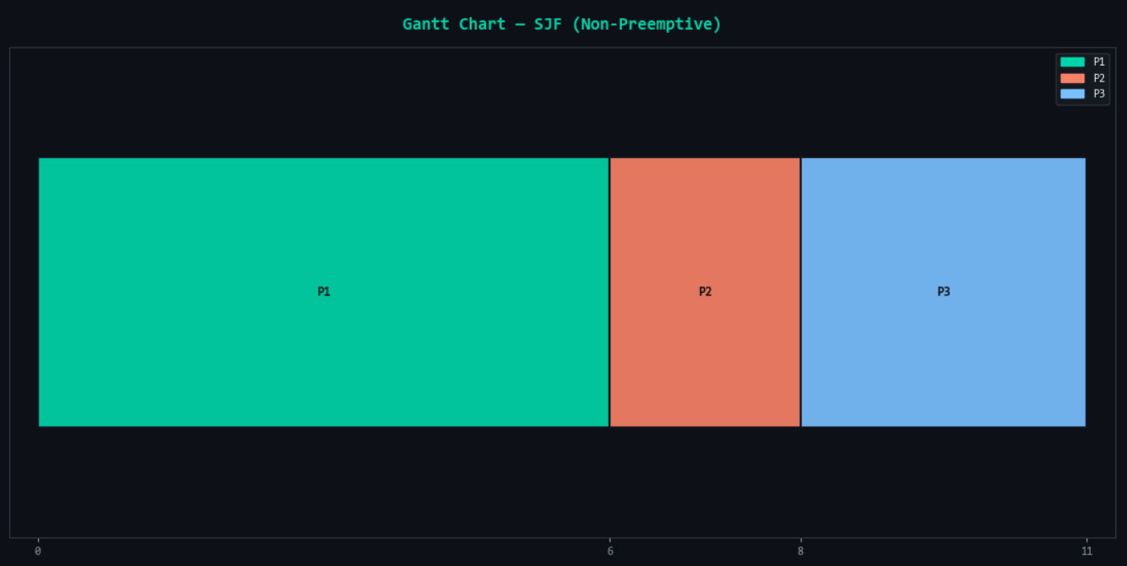
Process | Waiting Time | Turnaround Time
P1 | 0 | 6
P2 | 5 | 7
P3 | 6 | 9
Average | 3.67 | 7.33
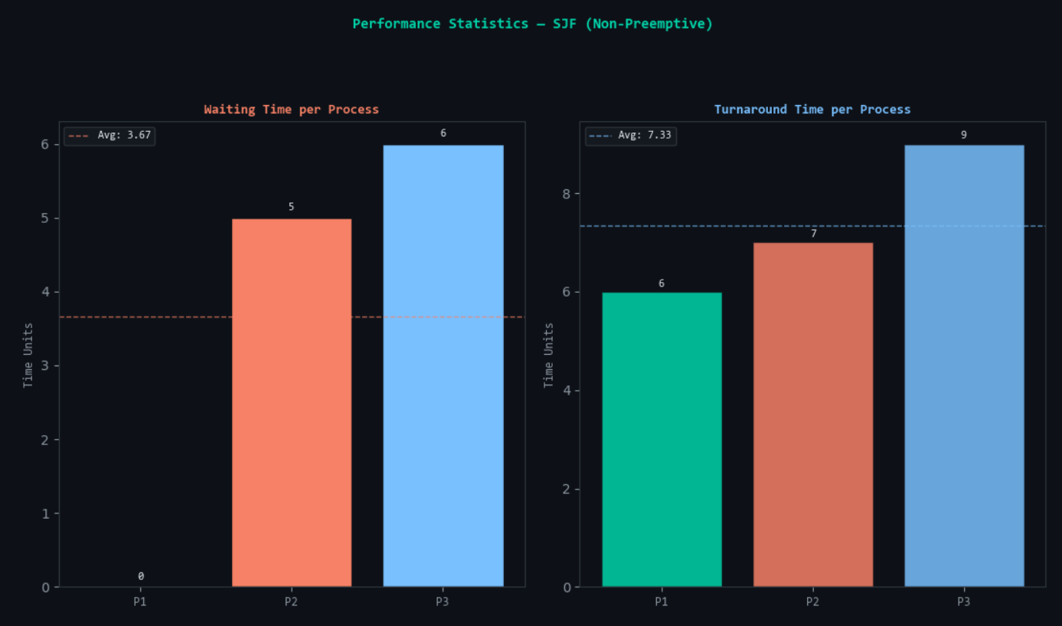
--------------------------------------------------------------------------------

2.3. Shortest Remaining Time (SRT) – Preemptive
- Mechanism: A preemptive version of SJF. If a new process arrives with a shorter remaining burst time than the currently running process, the CPU is preempted.
- Status: Preemptive.
- Advantages: Provides excellent responsiveness for short tasks.
- Limitations: High context-switching overhead. The system must monitor remaining times at every clock tick or arrival event.
Architect’s Note: SRT represents the theoretical ideal for minimizing wait time. However, the cost of frequent context switches (saving/restoring registers) can degrade actual system performance if process granularity is too small.

Test Case 1
Process ID | Arrival Time | Burst Time
P1 | 0 | 8
P2 | 1 | 4
P3 | 2 | 9
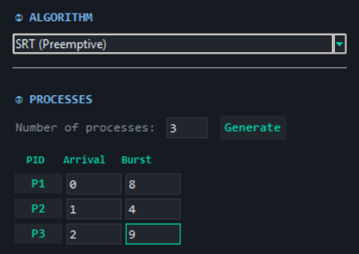
Gantt Chart: [P1 | 0-1][P2 | 1-5][P1 | 5-12][P3 | 12-21]
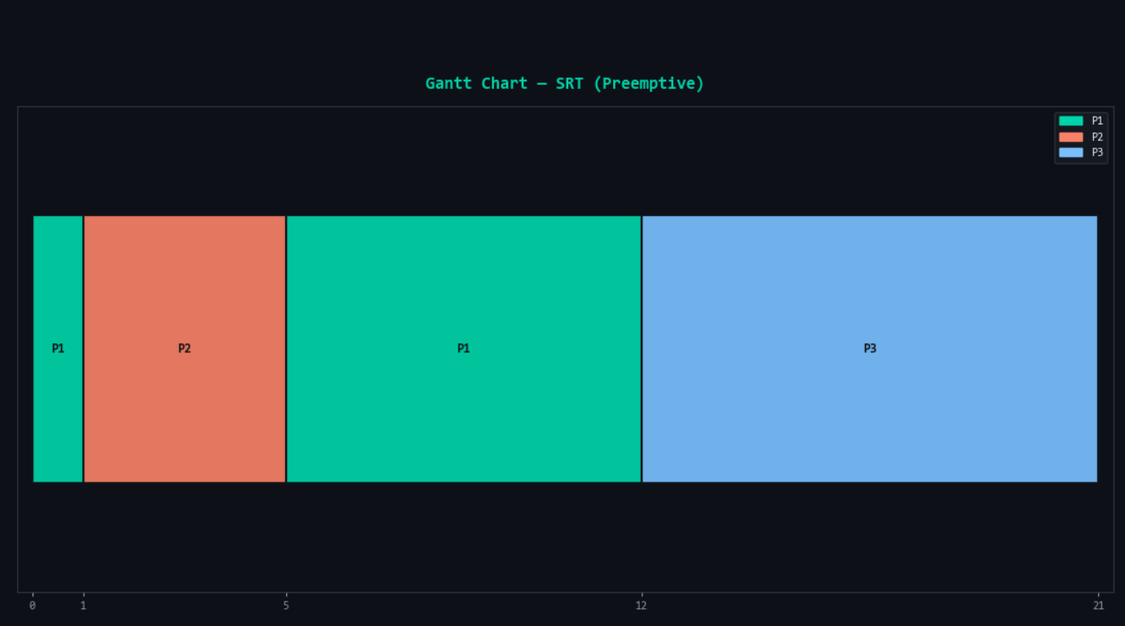
Process | Waiting Time | Turnaround Time
P1 | 4 | 12
P2 | 0 | 4
P3 | 10 | 19
Average | 4.67 | 11.67

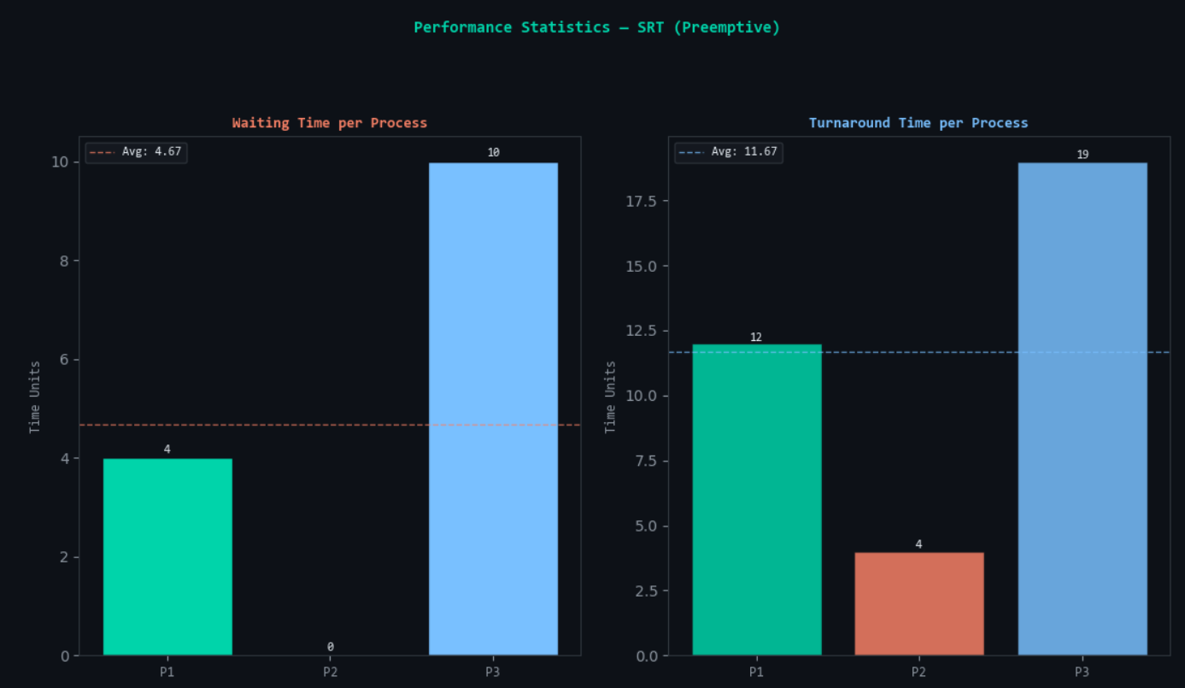

Test Case 2
Process ID | Arrival Time | Burst Time
P1 | 0 | 8
P2 | 1 | 2
P3 | 2 | 1
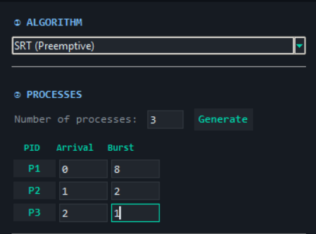
Gantt Chart: [P1 | 0-1][P2 | 1-2][P3 | 2-3][P2 | 3-4][P1 | 4-11]
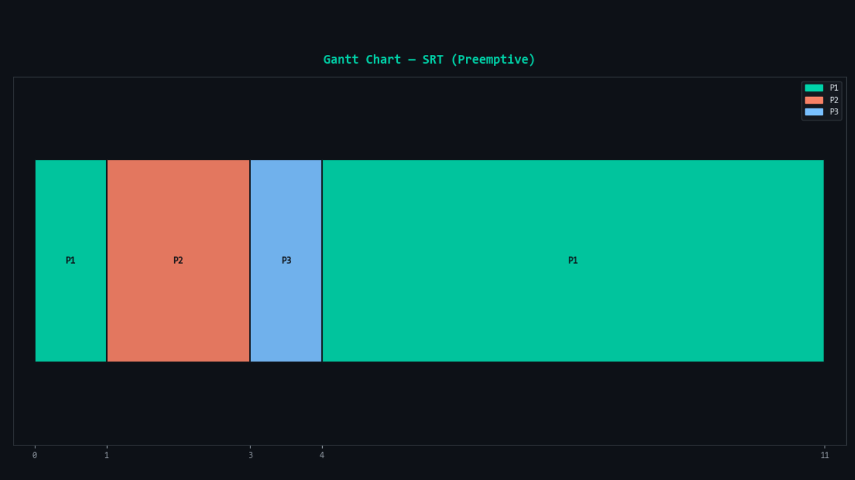
Process | Waiting Time | Turnaround Time
P1 | 3 | 11
P2 | 1 | 3
P3 | 0 | 1
Average | 1.33 | 5.00
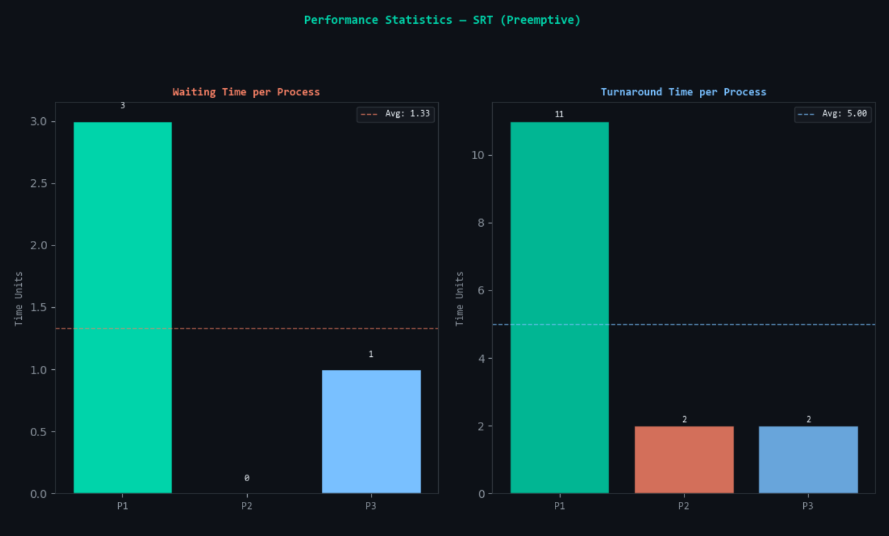
--------------------------------------------------------------------------------

2.4. Round Robin (RR)
- Mechanism: Each process is assigned a Time Quantum (Q). The CPU cycles through the ready queue, executing each process for at most Q units before moving to the next.
- Status: Preemptive.
- Advantages: Guaranteed fairness; optimal for time-sharing systems where responsiveness is key.
- Limitations: Performance depends heavily on Q. If Q is too large, RR behaves like FCFS; if too small, context switching overhead dominates.
Architect’s Note: In this simulation, the compress_timeline function is vital for RR. It translates the high-frequency oscillation of the CPU into a human-readable Gantt chart by merging contiguous execution blocks of the same PID.

Test Case 1 (Quantum = 4)
Process ID | Arrival Time | Burst Time
P1 | 0 | 10
P2 | 0 | 5
P3 | 0 | 8
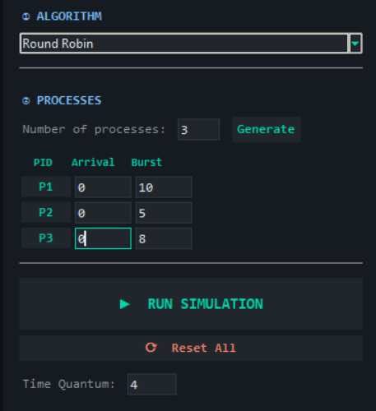
Gantt Chart: [P1 | 0-4][P2 | 4-8][P3 | 8-12][P1 | 12-16][P2 | 16-17][P3 | 17-21][P1 | 21-23]
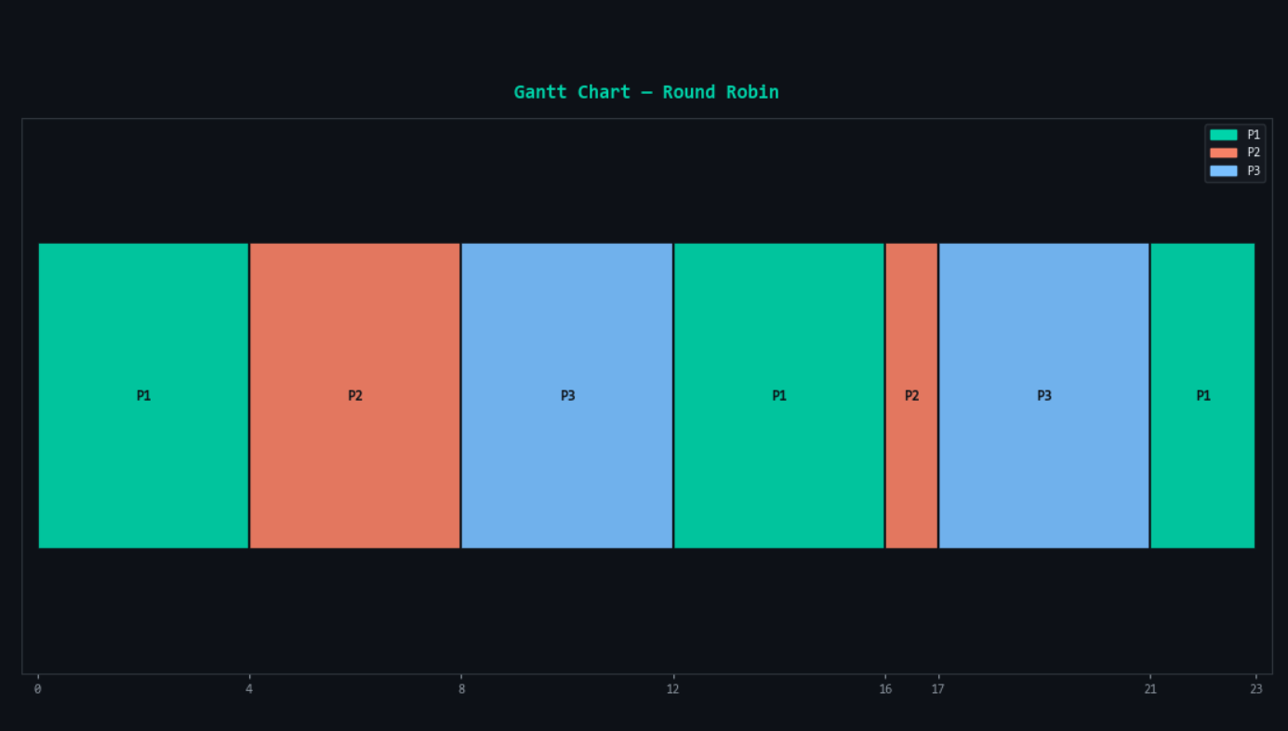
Process | Waiting Time | Turnaround Time
P1 | 13 | 23
P2 | 12 | 17
P3 | 13 | 21
Average | 12.67 | 20.33

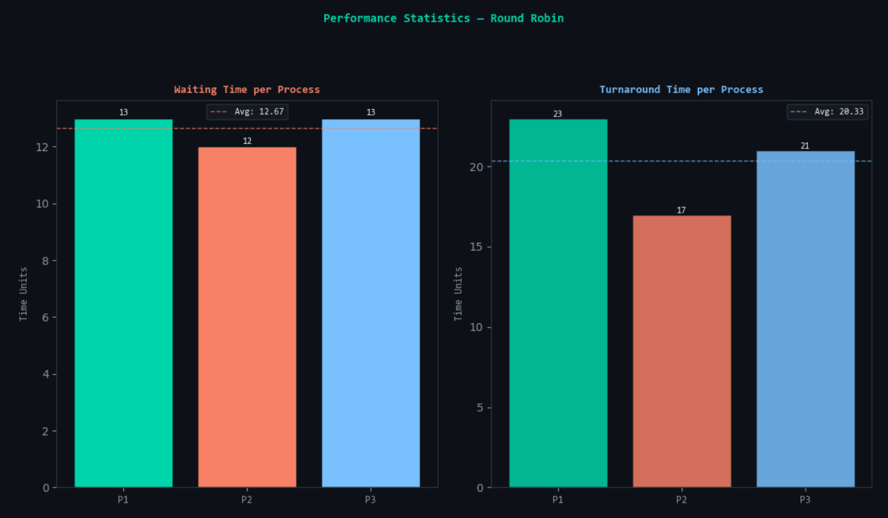

Test Case 2 (Quantum = 2)
Process ID | Arrival Time | Burst Time
P1 | 0 | 5
P2 | 0 | 5
P3 | 0 | 5
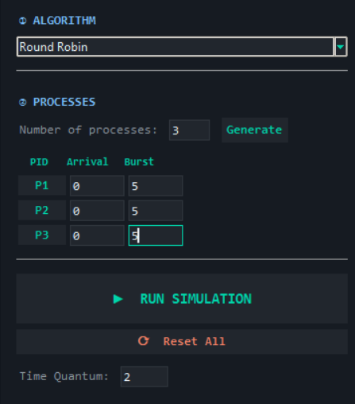
Gantt Chart: [P1|0-2][P2|2-4][P3|4-6][P1|6-8][P2|8-10][P3|10-12][P1|12-13][P2|13-14][P3|14-15]
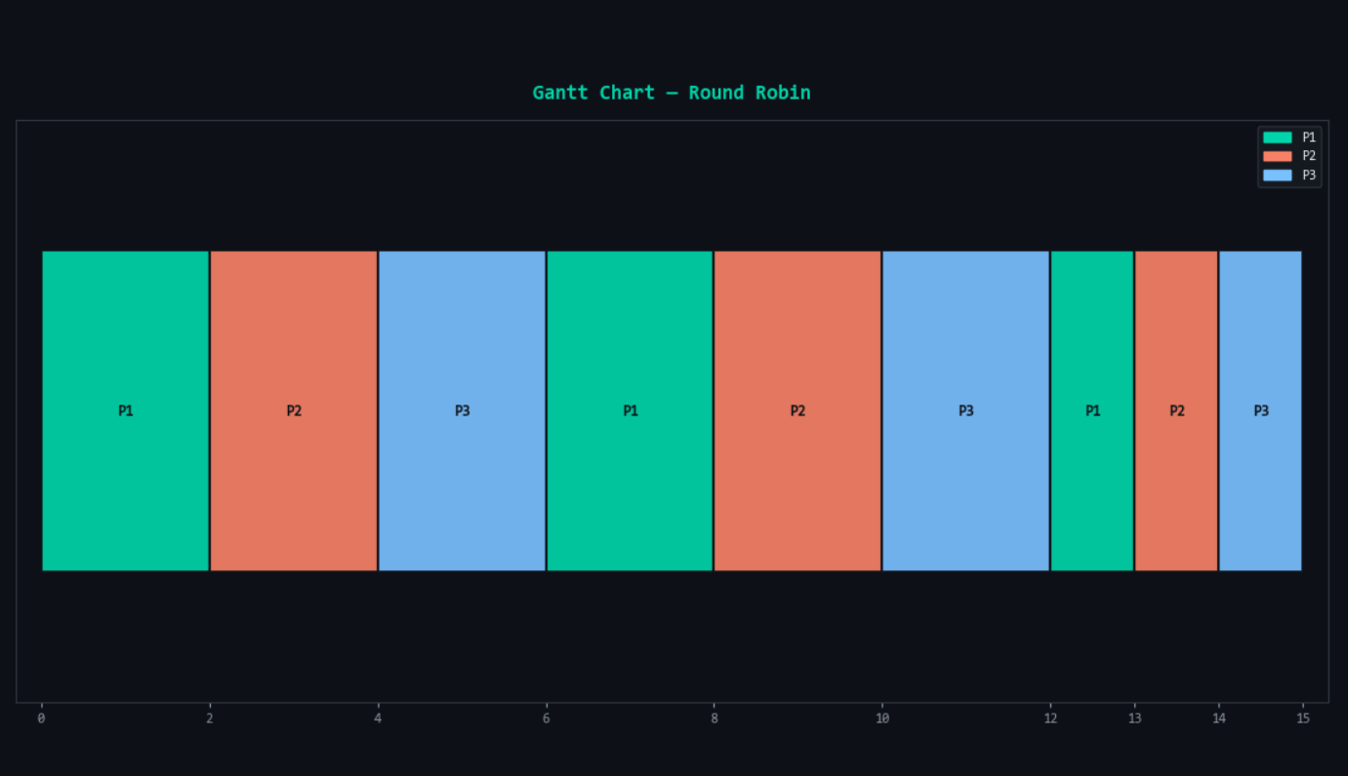
Process | Waiting Time | Turnaround Time
P1 | 8 | 13
P2 | 9 | 14
P3 | 10 | 15
Average | 9.00 | 14.00
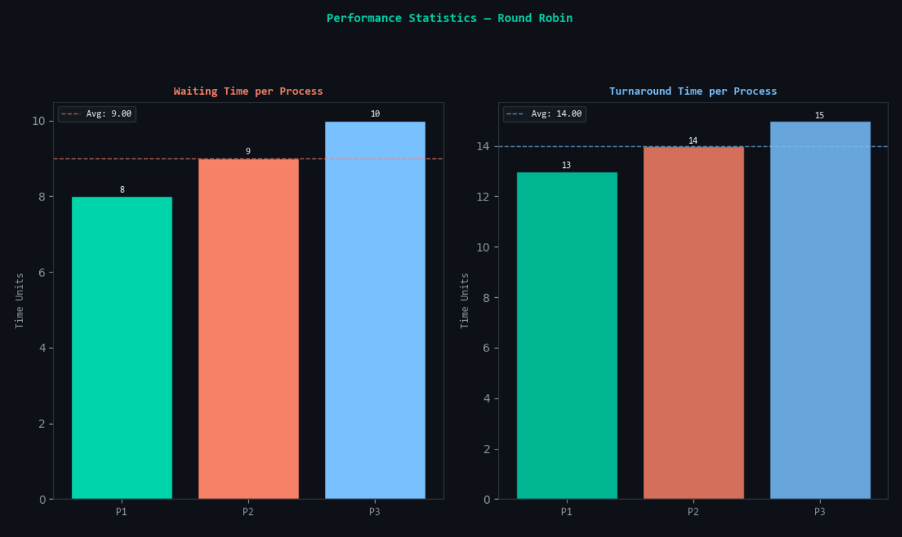
--------------------------------------------------------------------------------

2.5. Priority Scheduling
- Mechanism: Each process is assigned a priority value. The process with the highest priority (lower numerical value in this simulation) is selected first.
- Status: Non-preemptive (as per simulator constraints).
- Advantages: Allows mission-critical tasks to take precedence over background work.
- Limitations: Starvation of low-priority processes if a steady stream of high-priority tasks enters the queue.
Architect’s Note: To prevent starvation in a production system, one would implement "aging," where a process's priority increases the longer it waits in the ready queue. Our simulator supports priority toggling via the higher_is_better parameter.

Test Case 1 (Lower Value = Higher Priority)
Process ID | Arrival Time | Burst Time | Priority
P1 | 0 | 10 | 3
P2 | 0 | 1 | 1
P3 | 0 | 2 | 4
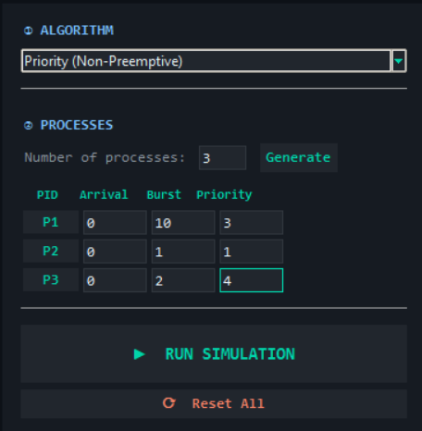
Gantt Chart: [P2 | 0-1][P1 | 1-11][P3 | 11-13]
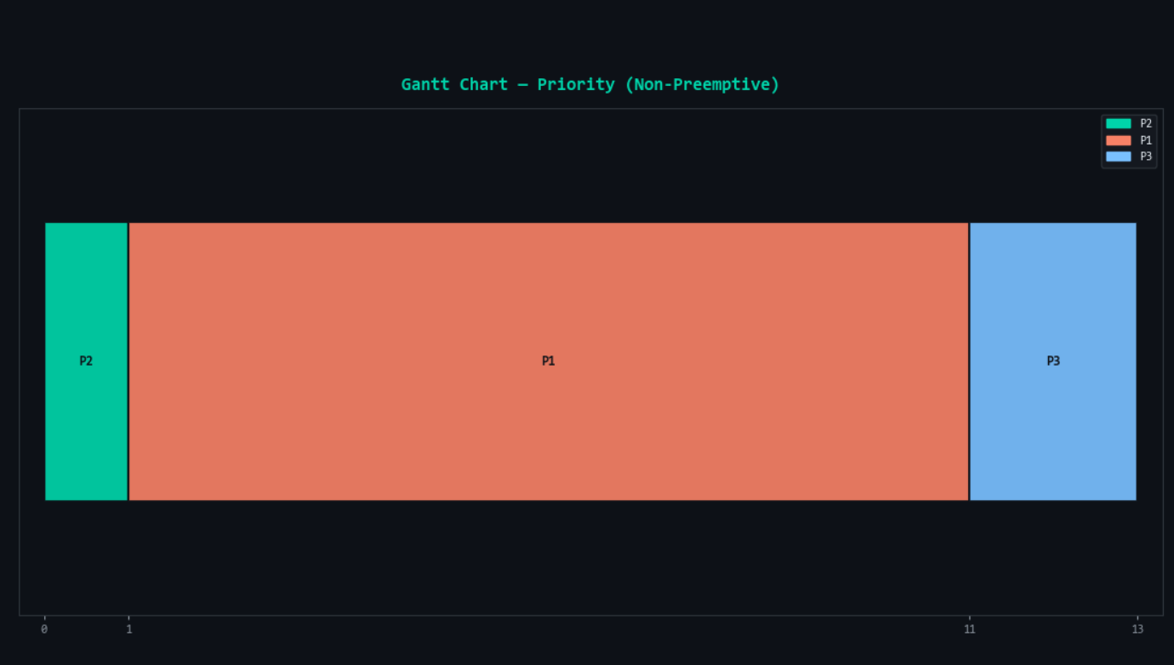
Process | Waiting Time | Turnaround Time
P1 | 1 | 11
P2 | 0 | 1
P3 | 11 | 13
Average | 4.00 | 8.33

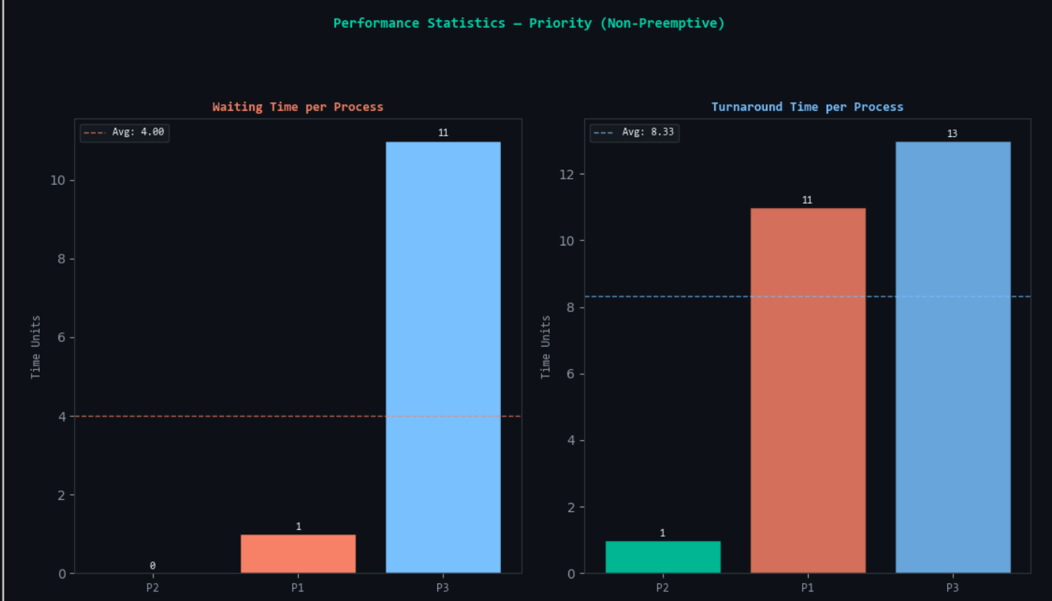

Test Case 2 (Lower Value = Higher Priority)
Process ID | Arrival Time | Burst Time | Priority
P1 | 0 | 5 | 2
P2 | 1 | 3 | 1
P3 | 2 | 8 | 3
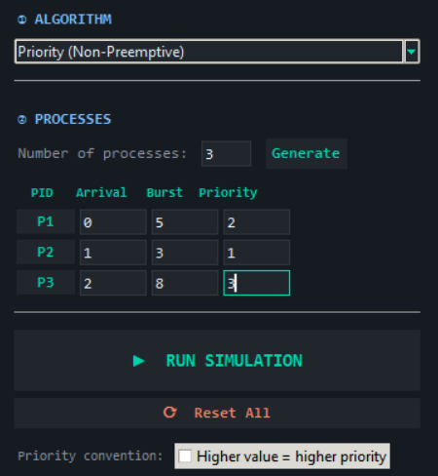
Gantt Chart: [P1 | 0-5][P2 | 5-8][P3 | 8-16] (Note: P1 executes first because it is the only process at Time 0; P2 must wait despite having higher priority).
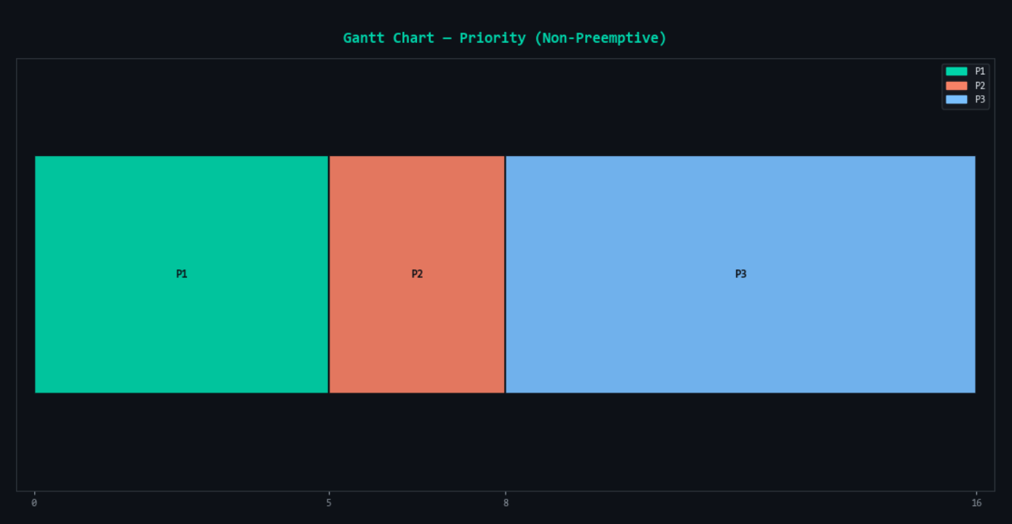
Process | Waiting Time | Turnaround Time
P1 | 0 | 5
P2 | 4 | 7
P3 | 6 | 14
Average | 3.33 | 8.67
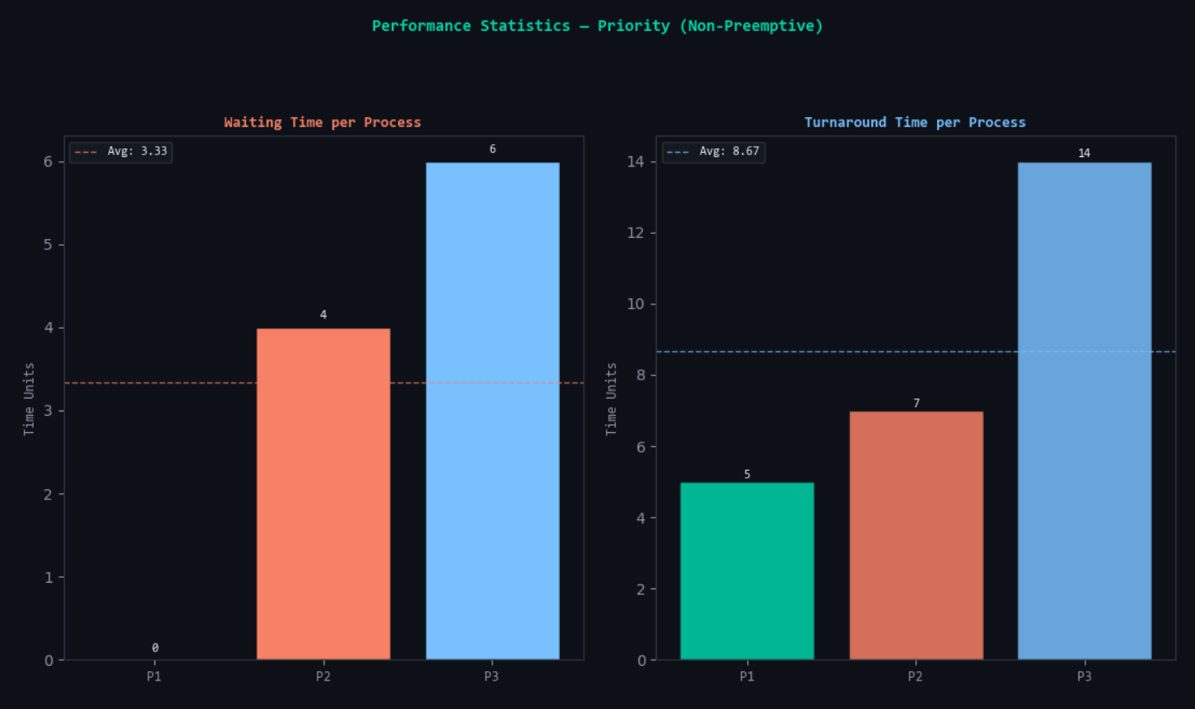
--------------------------------------------------------------------------------

2.6. Priority Scheduling with Round Robin
- Mechanism: This hybrid model groups processes by priority level. The scheduler processes the highest priority group first. If multiple processes exist within that group, Round Robin is used to ensure fairness among them.
- Status: Preemptive (within priority tiers).
- Advantages: Combines the urgency of priority systems with the fair-share allocation of Round Robin.
Architect’s Note: This algorithm mimics the behavior of Multi-Level Queue scheduling. It effectively mitigates total starvation within a priority class but still requires upper-tier management to ensure lower-priority groups eventually receive CPU cycles.

Test Case 1 (Quantum = 2, Lower Value = Higher Priority)
Process ID | Arrival Time | Burst Time | Priority
P1 | 0 | 4 | 1
P2 | 0 | 4 | 1
P3 | 0 | 2 | 2
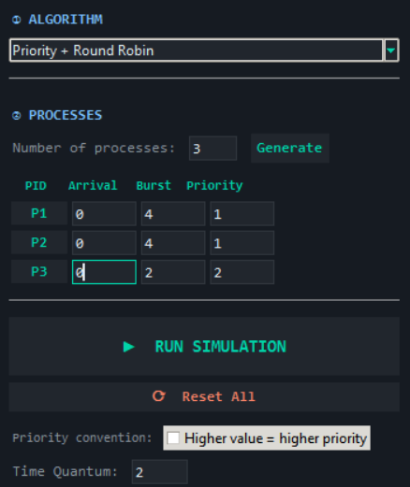
Gantt Chart: [P1 | 0-2][P2 | 2-4][P1 | 4-6][P2 | 6-8][P3 | 8-10]
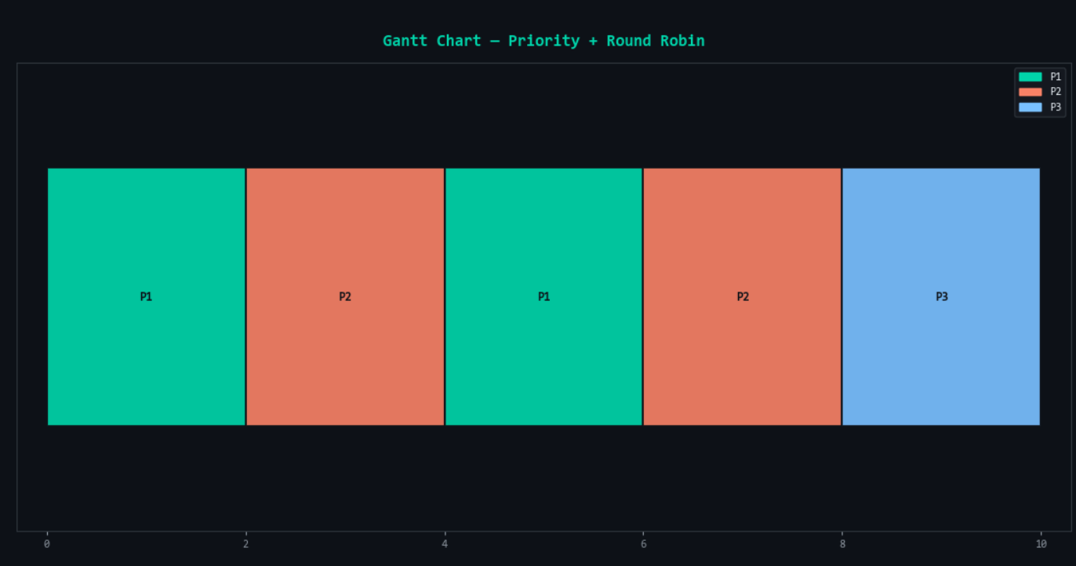
Process | Waiting Time | Turnaround Time
P1 | 2 | 6
P2 | 4 | 8
P3 | 8 | 10
Average | 4.67 | 8.00

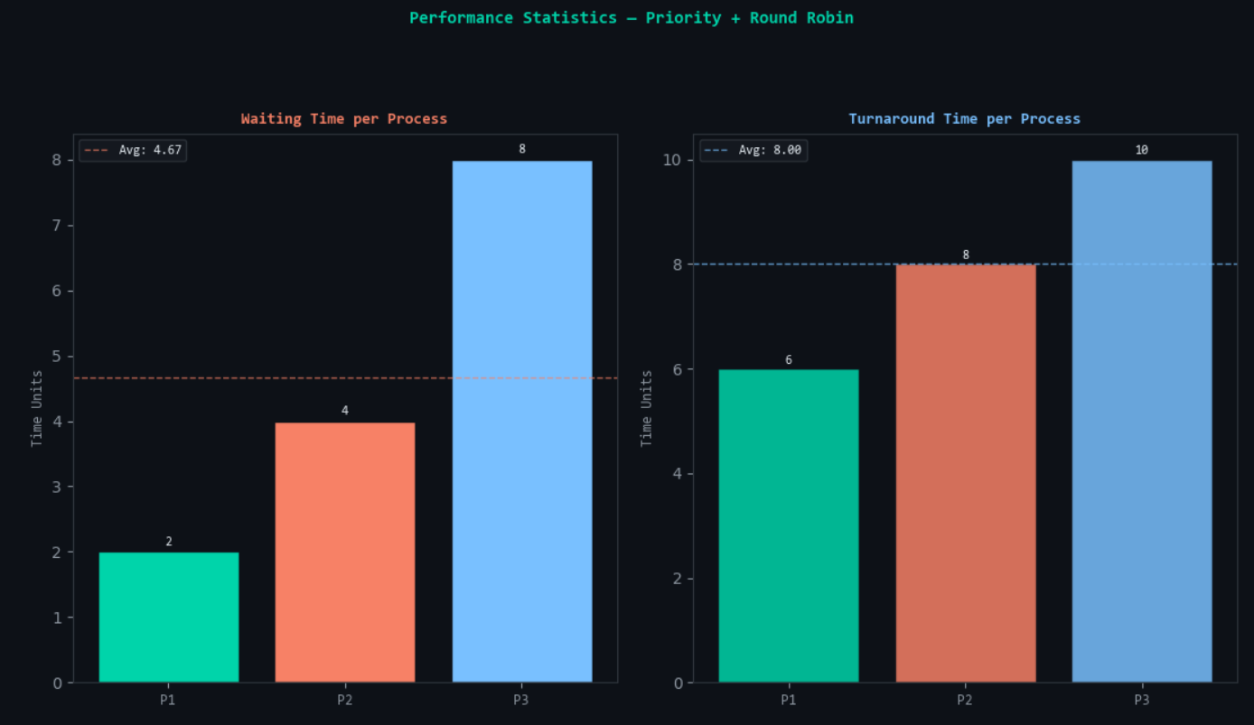

Test Case 2 (Quantum = 2, Lower Value = Higher Priority)
Process ID | Arrival Time | Burst Time | Priority
P1 | 0 | 6 | 2
P2 | 0 | 2 | 1
P3 | 0 | 2 | 1
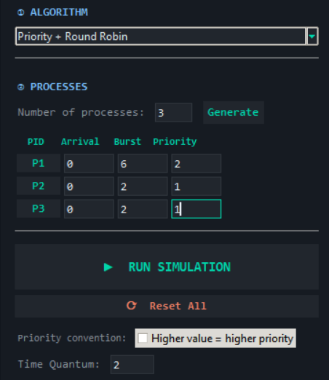
Gantt Chart: [P2 | 0-2][P3 | 2-4][P1 | 4-10]
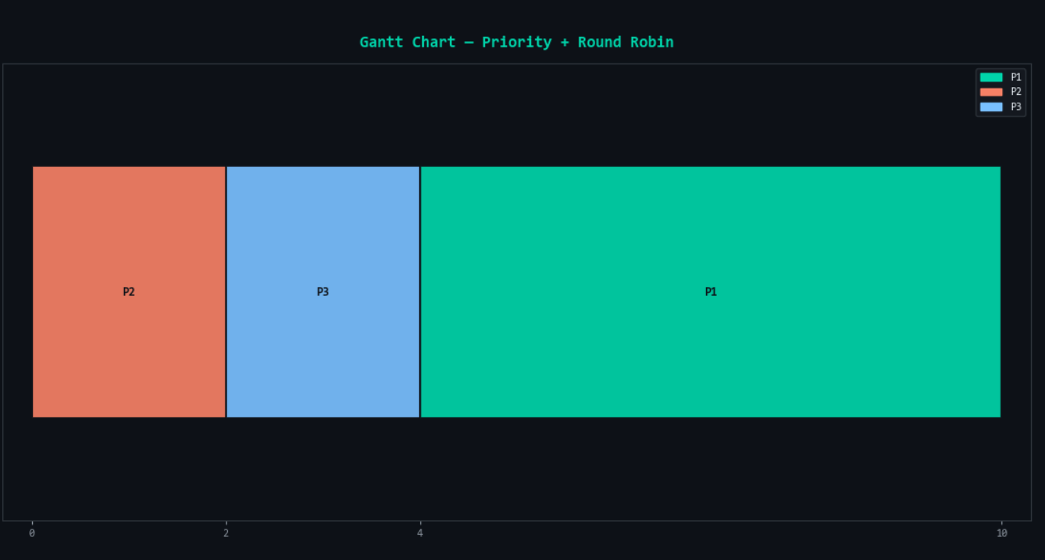
Process | Waiting Time | Turnaround Time
P1 | 4 | 10
P2 | 0 | 2
P3 | 2 | 4
Average | 2.00 | 5.33
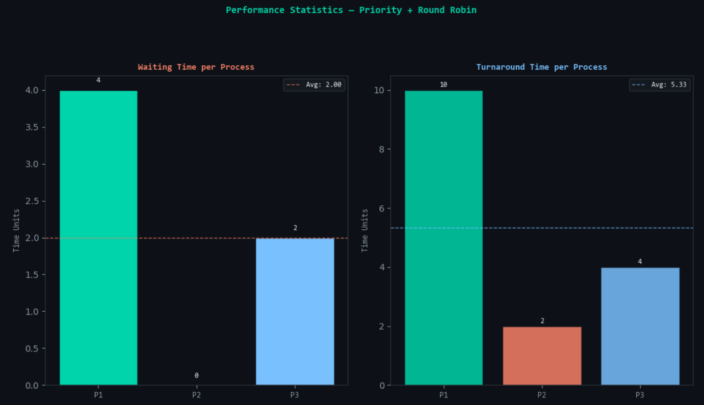
--------------------------------------------------------------------------------

3. Performance Summary and Reflective Takeaways

Comparative Analysis
The simulation demonstrates a clear trade-off between efficiency (SJF/SRT) and fairness (RR). SJF consistently yields the lowest average waiting times but creates unpredictability for longer tasks. Round Robin provides the most consistent response times for interactive processes but incurs the highest average turnaround time due to time-slicing. Priority scheduling allows for architectural control over task urgency, while the Priority+RR hybrid offers the most balanced approach for complex workloads.

Practical Relevance
The logic implemented in this simulation is directly foundational to the schedulers in the Linux kernel (Completely Fair Scheduler) and the Windows Dispatcher. While real-world OSs add complexities like multi-core affinity and hardware interrupts, the core principles of preemption and priority-based queue management remain identical to those demonstrated here.

Implementation Challenges
The most significant technical challenge was managing preemption logic. Implementing SRT and RR required a discrete-event simulation approach where the state of the system is re-evaluated at every time unit. Additionally, to maintain the integrity of the data across multiple algorithm simulations, the use of copy.deepcopy was essential to prevent the mutation of the original process objects (Arrival and Burst times) during the execution of each algorithm.

Insights Gained
Developing this simulator clarified the importance of the Time Quantum. A quantum that is too large negates the benefits of preemption, while one that is too small highlights the massive overhead of context switching. These insights are vital for any systems architect designing performance-critical software.
--------------------------------------------------------------------------------

4. References
- Case Study CPU Scheduling V2.pdf. (n.d.). Operating Systems Course Material.
- American Psychological Association. (2020). Publication manual of the American Psychological Association (7th ed.).
- Python Software Foundation. (2023). Tkinter and Matplotlib Documentation for GUI and Visualization.
--------------------------------------------------------------------------------

5. Repository and Demonstration Link
GitHub Repository Link: https://github.com/[YourUsername]/CPU-Scheduler-Simulator
Repository Contents:
- Video Demonstration: A 5-8 minute split-screen presentation (Face + Screen) featuring a voice-over explanation of the program input, Gantt chart generation, and average WT/TAT calculations.
- Source Code: Modular Python scripts including the simulation engine and the tkinter GUI.
- Executable File: A standalone .exe version of the simulator.
- Instructions: A detailed README.md file with installation requirements (pip install matplotlib) and execution steps.
--------------------------------------------------------------------------------

6. Source Code Appendix
"""
CPU Scheduling Algorithms Simulator
=====================================
A high-class Python GUI application simulating:
1. First-Come, First-Served (FCFS)
2. Shortest Job First (SJF) – Non-preemptive
3. Shortest Remaining Time (SRT) – Preemptive
4. Round Robin (RR)
5. Priority Scheduling (Non-preemptive)
6. Priority Scheduling with Round Robin
"""
import tkinter as tk
from tkinter import ttk, messagebox, font as tkfont
import matplotlib
matplotlib.use("TkAgg")
import matplotlib.pyplot as plt
import matplotlib.patches as mpatches
from matplotlib.backends.backend_tkagg import FigureCanvasTkAgg
import matplotlib.gridspec as gridspec
from collections import deque
import copy
# ─────────────────────────────────────────────
# COLOR PALETTE (dark industrial-tech theme)
# ─────────────────────────────────────────────
BG_DARK = "#0d1117"
BG_CARD = "#161b22"
BG_INPUT = "#21262d"
ACCENT = "#00d4aa" # teal-mint
ACCENT2 = "#f78166" # coral
ACCENT3 = "#79c0ff" # blue
TEXT_MAIN = "#e6edf3"
TEXT_SUB = "#8b949e"
BORDER = "#30363d"
HIGHLIGHT = "#1f6feb"
SUCCESS = "#3fb950"
WARNING = "#d29922"
PROC_COLORS = [
"#00d4aa", "#f78166", "#79c0ff", "#d2a8ff",
"#ffa657", "#7ee787", "#ff7b72", "#56d364",
"#e3b341", "#a5d6ff", "#ffa198", "#b1f0c1",
]
# ─────────────────────────────────────────────
# SCHEDULING ALGORITHMS
# ─────────────────────────────────────────────
class Process:
"""Represents a single process with all scheduling attributes."""
def __init__(self, pid, arrival, burst, priority=0):
self.pid = pid
self.arrival = arrival
self.burst = burst
self.priority = priority
self.remaining = burst
self.start = -1
self.finish = -1
self.waiting = 0
self.turnaround = 0
def compute_times(processes):
"""Calculate WT and TAT for each process after simulation."""
for p in processes:
p.turnaround = p.finish - p.arrival
p.waiting = p.turnaround - p.burst
def fcfs(processes):
"""
First-Come, First-Served (FCFS) – Non-preemptive.
Processes execute in order of arrival time.
Returns timeline list of (pid, start, end).
"""
procs = sorted(copy.deepcopy(processes), key=lambda x: (x.arrival, x.pid))
timeline = []
time = 0
for p in procs:
if time < p.arrival:
time = p.arrival # CPU idle gap
p.start = time
p.finish = time + p.burst
timeline.append((p.pid, p.start, p.finish))
time = p.finish
compute_times(procs)
return procs, timeline
def sjf_non_preemptive(processes):
"""
Shortest Job First (SJF) – Non-preemptive.
At each decision point, pick the ready process with shortest burst.
"""
procs = copy.deepcopy(processes)
done = []
timeline = []
time = 0
remaining = list(procs)
while remaining:
# Available processes that have arrived
ready = [p for p in remaining if p.arrival <= time]
if not ready:
time = min(p.arrival for p in remaining)
continue
# Pick shortest burst (tie-break: arrival, then pid)
chosen = min(ready, key=lambda x: (x.burst, x.arrival, x.pid))
remaining.remove(chosen)
chosen.start = time
chosen.finish = time + chosen.burst
timeline.append((chosen.pid, chosen.start, chosen.finish))
time = chosen.finish
done.append(chosen)
compute_times(done)
return done, timeline
def srt_preemptive(processes):
"""
Shortest Remaining Time (SRT) – Preemptive version of SJF.
At every time unit, run the process with the shortest remaining burst.
"""
procs = copy.deepcopy(processes)
n = len(procs)
time = 0
done = 0
timeline_raw = []
for p in procs:
p.remaining = p.burst
max_time = sum(p.burst for p in procs) + max(p.arrival for p in procs) + 1
while done < n and time < max_time:
ready = [p for p in procs if p.arrival <= time and p.finish == -1 and p.remaining > 0]
if not ready:
time += 1
continue
chosen = min(ready, key=lambda x: (x.remaining, x.arrival, x.pid))
if chosen.start == -1:
chosen.start = time
timeline_raw.append(chosen.pid)
chosen.remaining -= 1
time += 1
if chosen.remaining == 0:
chosen.finish = time
done += 1
# Compress timeline_raw into (pid, start, end) segments
timeline = compress_timeline(timeline_raw)
compute_times(procs)
return procs, timeline
def round_robin(processes, quantum):
"""
Round Robin (RR) – Preemptive with fixed time quantum.
Each process gets at most 'quantum' units per turn.
"""
procs = copy.deepcopy(processes)
for p in procs:
p.remaining = p.burst
queue = deque()
timeline_raw = []
time = 0
arrived = set()
done = 0
n = len(procs)
procs_sorted = sorted(procs, key=lambda x: (x.arrival, x.pid))
# Seed initial arrivals at time 0
for p in procs_sorted:
if p.arrival <= time:
queue.append(p)
arrived.add(p.pid)
while done < n:
if not queue:
# Jump to next arrival
future = [p for p in procs_sorted if p.pid not in arrived]
if not future:
break
time = min(p.arrival for p in future)
for p in procs_sorted:
if p.arrival <= time and p.pid not in arrived:
queue.append(p)
arrived.add(p.pid)
continue
current = queue.popleft()
if current.start == -1:
current.start = time
run = min(quantum, current.remaining)
for _ in range(run):
timeline_raw.append(current.pid)
time += 1
# Check for new arrivals at each tick
for p in procs_sorted:
if p.arrival <= time and p.pid not in arrived:
queue.append(p)
arrived.add(p.pid)
current.remaining -= run
if current.remaining == 0:
current.finish = time
done += 1
else:
queue.append(current)
timeline = compress_timeline(timeline_raw)
compute_times(procs)
return procs, timeline
def priority_non_preemptive(processes, higher_is_better=False):
"""
Priority Scheduling – Non-preemptive.
Lower priority number = higher priority by default (can be inverted).
At each decision point, pick ready process with best priority.
"""
procs = copy.deepcopy(processes)
done = []
timeline = []
time = 0
remaining = list(procs)
while remaining:
ready = [p for p in remaining if p.arrival <= time]
if not ready:
time = min(p.arrival for p in remaining)
continue
if higher_is_better:
chosen = max(ready, key=lambda x: (x.priority, -x.arrival))
else:
chosen = min(ready, key=lambda x: (x.priority, x.arrival))
remaining.remove(chosen)
chosen.start = time
chosen.finish = time + chosen.burst
timeline.append((chosen.pid, chosen.start, chosen.finish))
time = chosen.finish
done.append(chosen)
compute_times(done)
return done, timeline
def priority_round_robin(processes, quantum, higher_is_better=False):
"""
Priority Scheduling with Round Robin.
Processes grouped by priority; within same priority, RR is applied.
"""
procs = copy.deepcopy(processes)
for p in procs:
p.remaining = p.burst
timeline_raw = []
time = 0
done = 0
n = len(procs)
arrived = set()
procs_sorted = sorted(procs, key=lambda x: (x.arrival, x.pid))
def best_priority(candidates):
if higher_is_better:
return max(c.priority for c in candidates)
else:
return min(c.priority for c in candidates)
queue = deque()
for p in procs_sorted:
if p.arrival <= time:
queue.append(p)
arrived.add(p.pid)
while done < n:
if not queue:
future = [p for p in procs_sorted if p.pid not in arrived]
if not future:
break
time = min(p.arrival for p in future)
for p in procs_sorted:
if p.arrival <= time and p.pid not in arrived:
queue.append(p)
arrived.add(p.pid)
continue
# Find best priority among queued
bp = best_priority(list(queue))
# Reorder: move non-best-priority processes to back, best to front
top = [p for p in queue if p.priority == bp]
rest = [p for p in queue if p.priority != bp]
queue = deque(top + rest)
current = queue.popleft()
if current.start == -1:
current.start = time
run = min(quantum, current.remaining)
for _ in range(run):
timeline_raw.append(current.pid)
time += 1
for p in procs_sorted:
if p.arrival <= time and p.pid not in arrived:
queue.append(p)
arrived.add(p.pid)
current.remaining -= run
if current.remaining == 0:
current.finish = time
done += 1
else:
# Re-insert; new arrivals may have changed best priority
queue.append(current)
timeline = compress_timeline(timeline_raw)
compute_times(procs)
return procs, timeline
def compress_timeline(raw):
"""Convert a flat list of PIDs into compressed (pid, start, end) segments."""
if not raw:
return []
segments = []
start = 0
current = raw[0]
for i in range(1, len(raw)):
if raw[i] != current:
segments.append((current, start, i))
start = i
current = raw[i]
segments.append((current, start, len(raw)))
return segments
def avg(lst):
return sum(lst) / len(lst) if lst else 0
# ─────────────────────────────────────────────
# MAIN APPLICATION
# ─────────────────────────────────────────────
class CPUSchedulerApp(tk.Tk):
def __init__(self):
super().__init__()
self.title("CPU Scheduling Simulator")
self.geometry("1340x880")
self.configure(bg=BG_DARK)
self.minsize(1100, 720)
self._setup_styles()
self._build_ui()
# ── Styles ──────────────────────────────
def _setup_styles(self):
self.style = ttk.Style(self)
self.style.theme_use("clam")
# Frame / Label
self.style.configure("Dark.TFrame", background=BG_DARK)
self.style.configure("Card.TFrame", background=BG_CARD)
self.style.configure("Dark.TLabel", background=BG_DARK, foreground=TEXT_MAIN,
font=("Consolas", 10))
self.style.configure("Card.TLabel", background=BG_CARD, foreground=TEXT_MAIN,
font=("Consolas", 10))
self.style.configure("Title.TLabel", background=BG_DARK, foreground=ACCENT,
font=("Consolas", 20, "bold"))
self.style.configure("Sub.TLabel", background=BG_DARK, foreground=TEXT_SUB,
font=("Consolas", 9))
self.style.configure("SectionH.TLabel", background=BG_CARD, foreground=ACCENT3,
font=("Consolas", 11, "bold"))
self.style.configure("Small.TLabel", background=BG_CARD, foreground=TEXT_SUB,
font=("Consolas", 8))
# Notebook / Tabs
self.style.configure("TNotebook", background=BG_DARK, borderwidth=0)
self.style.configure("TNotebook.Tab", background=BG_INPUT, foreground=TEXT_SUB,
font=("Consolas", 9, "bold"),
padding=[14, 6])
self.style.map("TNotebook.Tab",
background=[("selected", BG_CARD)],
foreground=[("selected", ACCENT)])
# Combobox
self.style.configure("TCombobox", fieldbackground=BG_INPUT,
background=BG_INPUT, foreground=TEXT_MAIN,
arrowcolor=ACCENT, selectbackground=BG_INPUT,
font=("Consolas", 10))
self.style.map("TCombobox",
fieldbackground=[("readonly", BG_INPUT)],
foreground=[("readonly", TEXT_MAIN)])
# Scrollbar
self.style.configure("Vertical.TScrollbar", background=BG_INPUT,
troughcolor=BG_DARK, arrowcolor=ACCENT)
# Treeview (results table)
self.style.configure("Result.Treeview",
background=BG_INPUT, foreground=TEXT_MAIN,
fieldbackground=BG_INPUT, rowheight=26,
font=("Consolas", 9))
self.style.configure("Result.Treeview.Heading",
background=BG_CARD, foreground=ACCENT,
font=("Consolas", 9, "bold"))
self.style.map("Result.Treeview",
background=[("selected", HIGHLIGHT)])
# Separator
self.style.configure("TSeparator", background=BORDER)
# ── Master Layout ───────────────────────
def _build_ui(self):
# Header
hdr = tk.Frame(self, bg=BG_DARK, height=64)
hdr.pack(fill="x", padx=0, pady=0)
hdr.pack_propagate(False)
tk.Label(hdr, text="⚙ CPU SCHEDULING SIMULATOR",
bg=BG_DARK, fg=ACCENT,
font=("Consolas", 18, "bold")).pack(side="left", padx=24, pady=12)
tk.Label(hdr, text="Operating Systems · Process Management",
bg=BG_DARK, fg=TEXT_SUB,
font=("Consolas", 9)).pack(side="left", padx=4, pady=20)
# Separator line
tk.Frame(self, bg=BORDER, height=1).pack(fill="x")
# Main pane: left config + right output
main = tk.Frame(self, bg=BG_DARK)
main.pack(fill="both", expand=True)
self._build_left(main)
self._build_right(main)
# ── LEFT PANEL ──────────────────────────
def _build_left(self, parent):
left = tk.Frame(parent, bg=BG_CARD, width=380)
left.pack(side="left", fill="y", padx=(10, 5), pady=10)
left.pack_propagate(False)
# Scrollable canvas for left panel
canvas = tk.Canvas(left, bg=BG_CARD, highlightthickness=0)
sb = ttk.Scrollbar(left, orient="vertical", command=canvas.yview)
canvas.configure(yscrollcommand=sb.set)
sb.pack(side="right", fill="y")
canvas.pack(side="left", fill="both", expand=True)
self.left_inner = tk.Frame(canvas, bg=BG_CARD)
win_id = canvas.create_window((0, 0), window=self.left_inner, anchor="nw")
def _on_configure(e):
canvas.configure(scrollregion=canvas.bbox("all"))
canvas.itemconfig(win_id, width=canvas.winfo_width())
self.left_inner.bind("<Configure>", _on_configure)
canvas.bind("<Configure>", lambda e: canvas.itemconfig(win_id, width=e.width))
self._bind_mousewheel(canvas)
self._fill_left(self.left_inner)
def _bind_mousewheel(self, widget):
def _mw(e):
widget.yview_scroll(int(-1*(e.delta/120)), "units")
widget.bind_all("<MouseWheel>", _mw)
def _fill_left(self, f):
pad = dict(padx=16, pady=4)
# ── Section: Algorithm ──
self._section_label(f, "① ALGORITHM")
self.algo_var = tk.StringVar(value="FCFS")
algos = ["FCFS", "SJF (Non-Preemptive)", "SRT (Preemptive)",
"Round Robin", "Priority (Non-Preemptive)", "Priority + Round Robin"]
cb = ttk.Combobox(f, textvariable=self.algo_var, values=algos,
state="readonly", width=34)
cb.pack(**pad, fill="x")
cb.bind("<<ComboboxSelected>>", self._on_algo_change)
# Priority direction
self.prio_frame = tk.Frame(f, bg=BG_CARD)
self.prio_frame.pack(**pad, fill="x")
tk.Label(self.prio_frame, text="Priority convention:",
bg=BG_CARD, fg=TEXT_SUB, font=("Consolas", 8)).pack(side="left")
self.higher_is_better = tk.BooleanVar(value=False)
ttk.Checkbutton(self.prio_frame, text="Higher value = higher priority",
variable=self.higher_is_better,
style="TCheckbutton").pack(side="left", padx=6)
self.prio_frame.pack_forget()
# Quantum
self.quantum_frame = tk.Frame(f, bg=BG_CARD)
self.quantum_frame.pack(**pad, fill="x")
tk.Label(self.quantum_frame, text="Time Quantum:",
bg=BG_CARD, fg=TEXT_SUB, font=("Consolas", 9)).pack(side="left")
self.quantum_var = tk.StringVar(value="2")
self._entry(self.quantum_frame, self.quantum_var, width=6).pack(side="left", padx=8)
self.quantum_frame.pack_forget()
ttk.Separator(f, orient="horizontal").pack(fill="x", padx=16, pady=8)
# ── Section: Processes ──
self._section_label(f, "② PROCESSES")
ctrl = tk.Frame(f, bg=BG_CARD)
ctrl.pack(**pad, fill="x")
tk.Label(ctrl, text="Number of processes:",
bg=BG_CARD, fg=TEXT_SUB, font=("Consolas", 9)).pack(side="left")
self.nproc_var = tk.StringVar(value="4")
self._entry(ctrl, self.nproc_var, width=5).pack(side="left", padx=8)
self._btn(ctrl, "Generate", self._generate_process_fields,
color=ACCENT).pack(side="left", padx=4)
# Process table header
self.proc_header = tk.Frame(f, bg=BG_CARD)
self.proc_header.pack(padx=16, pady=(6, 0), fill="x")
# Container for process rows
self.proc_rows_frame = tk.Frame(f, bg=BG_CARD)
self.proc_rows_frame.pack(padx=16, pady=2, fill="x")
self.proc_rows = [] # list of dicts {pid, arrival, burst, priority}
ttk.Separator(f, orient="horizontal").pack(fill="x", padx=16, pady=8)
# ── Run button ──
run_f = tk.Frame(f, bg=BG_CARD)
run_f.pack(padx=16, pady=6, fill="x")
self._btn(run_f, "▶ RUN SIMULATION", self._run_simulation,
color=ACCENT, font_size=11, height=2).pack(fill="x")
self._btn(f, "⟳ Reset All", self._reset_all,
color=ACCENT2).pack(padx=16, pady=(0, 8), fill="x")
# Initialise with default 4 processes
self._generate_process_fields()
def _section_label(self, parent, text):
tk.Label(parent, text=text, bg=BG_CARD, fg=ACCENT3,
font=("Consolas", 10, "bold")).pack(padx=16, pady=(12, 2), anchor="w")
def _entry(self, parent, var, width=8):
e = tk.Entry(parent, textvariable=var, width=width,
bg=BG_INPUT, fg=TEXT_MAIN, insertbackground=TEXT_MAIN,
relief="flat", font=("Consolas", 10),
highlightthickness=1, highlightbackground=BORDER,
highlightcolor=ACCENT)
return e
def _btn(self, parent, text, cmd, color=ACCENT, font_size=9, height=1):
b = tk.Button(parent, text=text, command=cmd,
bg=BG_INPUT, fg=color, activebackground=BG_CARD,
activeforeground=color, relief="flat",
font=("Consolas", font_size, "bold"),
cursor="hand2", height=height,
highlightthickness=1, highlightbackground=color)
b.bind("<Enter>", lambda e: b.config(bg=BG_CARD))
b.bind("<Leave>", lambda e: b.config(bg=BG_INPUT))
return b
def _on_algo_change(self, *_):
algo = self.algo_var.get()
uses_quantum = algo in ("Round Robin", "Priority + Round Robin")
uses_priority = algo in ("Priority (Non-Preemptive)", "Priority + Round Robin")
if uses_quantum:
self.quantum_frame.pack(padx=16, pady=4, fill="x",
before=self.proc_header.master.winfo_children()[
list(self.left_inner.winfo_children()).index(self.proc_rows_frame) - 2
] if False else None)
self.quantum_frame.pack(padx=16, pady=4, fill="x")
else:
self.quantum_frame.pack_forget()
if uses_priority:
self.prio_frame.pack(padx=16, pady=4, fill="x")
else:
self.prio_frame.pack_forget()
# Refresh rows to show/hide priority column
self._refresh_proc_header(uses_priority)
self._rebuild_proc_rows(uses_priority)
def _refresh_proc_header(self, show_priority):
for w in self.proc_header.winfo_children():
w.destroy()
cols = [("PID", 6), ("Arrival", 7), ("Burst", 7)]
if show_priority:
cols.append(("Priority", 7))
for name, w in cols:
tk.Label(self.proc_header, text=name, bg=BG_CARD, fg=ACCENT,
font=("Consolas", 8, "bold"), width=w).pack(side="left", padx=2)
def _rebuild_proc_rows(self, show_priority):
"""Re-render rows keeping existing values."""
existing = []
for row in self.proc_rows:
existing.append({
"pid": row["pid"].cget("text"),
"arrival": row["arrival_var"].get(),
"burst": row["burst_var"].get(),
"priority": row["priority_var"].get() if "priority_var" in row else "0",
})
for w in self.proc_rows_frame.winfo_children():
w.destroy()
self.proc_rows.clear()
for d in existing:
self._add_proc_row(d["pid"], d["arrival"], d["burst"],
d["priority"], show_priority)
def _generate_process_fields(self):
try:
n = int(self.nproc_var.get())
if n < 3:
messagebox.showwarning("Input Error", "Minimum 3 processes required.")
return
if n > 12:
messagebox.showwarning("Input Error", "Maximum 12 processes supported.")
return
except ValueError:
messagebox.showerror("Input Error", "Enter a valid integer for number of processes.")
return
algo = self.algo_var.get()
uses_priority = algo in ("Priority (Non-Preemptive)", "Priority + Round Robin")
self._refresh_proc_header(uses_priority)
for w in self.proc_rows_frame.winfo_children():
w.destroy()
self.proc_rows.clear()
# Default sample values
defaults = [
("P1", "0", "6", "2"),
("P2", "1", "8", "1"),
("P3", "2", "7", "3"),
("P4", "3", "3", "4"),
("P5", "4", "4", "2"),
("P6", "5", "5", "5"),
("P7", "0", "2", "1"),
("P8", "1", "9", "3"),
("P9", "3", "4", "2"),
("P10","2", "6", "4"),
("P11","4", "3", "1"),
("P12","5", "8", "3"),
]
for i in range(n):
d = defaults[i] if i < len(defaults) else (f"P{i+1}", str(i), "5", "1")
self._add_proc_row(d[0], d[1], d[2], d[3], uses_priority)
def _add_proc_row(self, pid, arrival, burst, priority, show_priority):
row_frame = tk.Frame(self.proc_rows_frame, bg=BG_CARD)
row_frame.pack(fill="x", pady=2)
pid_lbl = tk.Label(row_frame, text=pid, bg=BG_INPUT, fg=ACCENT,
font=("Consolas", 9, "bold"), width=6, relief="flat")
pid_lbl.pack(side="left", padx=2)
arr_var = tk.StringVar(value=arrival)
bst_var = tk.StringVar(value=burst)
pri_var = tk.StringVar(value=priority)
self._entry(row_frame, arr_var, width=7).pack(side="left", padx=2)
self._entry(row_frame, bst_var, width=7).pack(side="left", padx=2)
row_data = {"pid": pid_lbl, "arrival_var": arr_var,
"burst_var": bst_var, "priority_var": pri_var,
"frame": row_frame}
if show_priority:
self._entry(row_frame, pri_var, width=7).pack(side="left", padx=2)
self.proc_rows.append(row_data)
# ── RIGHT PANEL ─────────────────────────
def _build_right(self, parent):
right = tk.Frame(parent, bg=BG_DARK)
right.pack(side="left", fill="both", expand=True, padx=(5, 10), pady=10)
self.notebook = ttk.Notebook(right)
self.notebook.pack(fill="both", expand=True)
# Tab 1: Gantt Chart
self.gantt_tab = tk.Frame(self.notebook, bg=BG_DARK)
self.notebook.add(self.gantt_tab, text=" 📊 Gantt Chart ")
# Tab 2: Results Table
self.table_tab = tk.Frame(self.notebook, bg=BG_DARK)
self.notebook.add(self.table_tab, text=" 📋 Results Table ")
# Tab 3: Statistics
self.stats_tab = tk.Frame(self.notebook, bg=BG_DARK)
self.notebook.add(self.stats_tab, text=" 📈 Statistics ")
self._init_gantt_tab()
self._init_table_tab()
self._init_stats_tab()
def _init_gantt_tab(self):
placeholder = tk.Label(self.gantt_tab,
text="Run a simulation to view the Gantt Chart.",
bg=BG_DARK, fg=TEXT_SUB,
font=("Consolas", 11))
placeholder.place(relx=0.5, rely=0.5, anchor="center")
self._gantt_placeholder = placeholder
def _init_table_tab(self):
# Summary cards row
self.summary_frame = tk.Frame(self.table_tab, bg=BG_DARK)
self.summary_frame.pack(fill="x", padx=10, pady=8)
# Treeview
cols = ("Process", "Arrival", "Burst", "Priority", "Start", "Finish",
"Waiting Time", "Turnaround Time")
frame = tk.Frame(self.table_tab, bg=BG_DARK)
frame.pack(fill="both", expand=True, padx=10, pady=(0, 8))
vsb = ttk.Scrollbar(frame, orient="vertical")
hsb = ttk.Scrollbar(frame, orient="horizontal")
self.result_tree = ttk.Treeview(frame, columns=cols, show="headings",
style="Result.Treeview",
yscrollcommand=vsb.set,
xscrollcommand=hsb.set)
vsb.config(command=self.result_tree.yview)
hsb.config(command=self.result_tree.xview)
for c in cols:
self.result_tree.heading(c, text=c)
self.result_tree.column(c, width=100, anchor="center", minwidth=70)
vsb.pack(side="right", fill="y")
hsb.pack(side="bottom", fill="x")
self.result_tree.pack(fill="both", expand=True)
def _init_stats_tab(self):
placeholder = tk.Label(self.stats_tab,
text="Run a simulation to view statistics.",
bg=BG_DARK, fg=TEXT_SUB,
font=("Consolas", 11))
placeholder.place(relx=0.5, rely=0.5, anchor="center")
self._stats_placeholder = placeholder
# ── SIMULATION RUNNER ───────────────────
def _run_simulation(self):
# Parse processes
algo = self.algo_var.get()
uses_priority = algo in ("Priority (Non-Preemptive)", "Priority + Round Robin")
try:
processes = []
for row in self.proc_rows:
pid = row["pid"].cget("text")
arrival = int(row["arrival_var"].get())
burst = int(row["burst_var"].get())
prio = int(row["priority_var"].get()) if uses_priority else 0
if arrival < 0 or burst <= 0:
raise ValueError(f"{pid}: Arrival ≥ 0 and Burst > 0 required.")
processes.append(Process(pid, arrival, burst, prio))
except ValueError as e:
messagebox.showerror("Input Error", str(e))
return
if len(processes) < 3:
messagebox.showwarning("Input Error", "Minimum 3 processes required.")
return
# Parse quantum
quantum = 2
if algo in ("Round Robin", "Priority + Round Robin"):
try:
quantum = int(self.quantum_var.get())
if quantum <= 0:
raise ValueError()
except ValueError:
messagebox.showerror("Input Error", "Time Quantum must be a positive integer.")
return
hib = self.higher_is_better.get()
# Run chosen algorithm
try:
if algo == "FCFS":
result, timeline = fcfs(processes)
elif algo == "SJF (Non-Preemptive)":
result, timeline = sjf_non_preemptive(processes)
elif algo == "SRT (Preemptive)":
result, timeline = srt_preemptive(processes)
elif algo == "Round Robin":
result, timeline = round_robin(processes, quantum)
elif algo == "Priority (Non-Preemptive)":
result, timeline = priority_non_preemptive(processes, hib)
elif algo == "Priority + Round Robin":
result, timeline = priority_round_robin(processes, quantum, hib)
else:
return
except Exception as e:
messagebox.showerror("Simulation Error", str(e))
return
self._render_gantt(timeline, result, algo)
self._render_table(result, uses_priority)
self._render_stats(result, algo)
self.notebook.select(self.gantt_tab)
def _render_gantt(self, timeline, processes, algo):
# Clear old widgets
for w in self.gantt_tab.winfo_children():
w.destroy()
pid_list = [p.pid for p in processes]
color_map = {p.pid: PROC_COLORS[i % len(PROC_COLORS)]
for i, p in enumerate(processes)}
if not timeline:
tk.Label(self.gantt_tab, text="No timeline data.",
bg=BG_DARK, fg=TEXT_SUB, font=("Consolas", 11)).pack(expand=True)
return
max_t = max(seg[2] for seg in timeline)
fig = plt.Figure(figsize=(11, 4.5), facecolor=BG_DARK)
ax = fig.add_subplot(111)
ax.set_facecolor(BG_DARK)
bar_height = 0.55
y_center = 0.5
for seg in timeline:
pid, start, end = seg
color = color_map.get(pid, "#ffffff")
ax.barh(y_center, end - start, left=start, height=bar_height,
color=color, edgecolor=BG_DARK, linewidth=1.5, alpha=0.92)
mid = (start + end) / 2
ax.text(mid, y_center, pid,
ha="center", va="center",
color=BG_DARK, fontweight="bold",
fontsize=9, fontfamily="Consolas")
# Time ticks
ticks = sorted(set(t for seg in timeline for t in [seg[1], seg[2]]))
ax.set_xticks(ticks)
ax.set_xticklabels([str(t) for t in ticks],
color=TEXT_SUB, fontsize=8, fontfamily="Consolas")
ax.set_xlim(-0.3, max_t + 0.3)
ax.set_ylim(0, 1)
ax.set_yticks([])
ax.tick_params(colors=TEXT_SUB, length=3)
for spine in ax.spines.values():
spine.set_edgecolor(BORDER)
ax.set_title(f"Gantt Chart — {algo}",
color=ACCENT, fontsize=12, fontfamily="Consolas",
fontweight="bold", pad=12)
# Legend
patches = [mpatches.Patch(color=color_map[p.pid], label=p.pid)
for p in processes]
ax.legend(handles=patches, loc="upper right",
facecolor=BG_CARD, edgecolor=BORDER,
labelcolor=TEXT_MAIN, fontsize=8,
prop={"family": "Consolas", "size": 8})
fig.tight_layout(rect=[0, 0.05, 1, 0.95])
canvas = FigureCanvasTkAgg(fig, master=self.gantt_tab)
canvas.draw()
canvas.get_tk_widget().pack(fill="both", expand=True, padx=8, pady=8)
plt.close(fig)
def _render_table(self, processes, show_priority):
# Clear tree
for item in self.result_tree.get_children():
self.result_tree.delete(item)
# Clear summary cards
for w in self.summary_frame.winfo_children():
w.destroy()
algo = self.algo_var.get()
color_map = {p.pid: PROC_COLORS[i % len(PROC_COLORS)]
for i, p in enumerate(processes)}
# Sort by PID for display
sorted_procs = sorted(processes, key=lambda p: p.pid)
tags_defined = set()
for p in sorted_procs:
tag = f"proc_{p.pid}"
if tag not in tags_defined:
self.result_tree.tag_configure(tag,
background=BG_INPUT,
foreground=color_map.get(p.pid, TEXT_MAIN))
tags_defined.add(tag)
vals = (p.pid, p.arrival, p.burst,
p.priority if show_priority else "—",
p.start, p.finish,
p.waiting, p.turnaround)
self.result_tree.insert("", "end", values=vals, tags=(tag,))
# Summary averages
awt = avg([p.waiting for p in processes])
atat = avg([p.turnaround for p in processes])
cpu_busy = sum(p.burst for p in processes)
span = max(p.finish for p in processes) - min(p.arrival for p in processes)
util = (cpu_busy / span * 100) if span > 0 else 100.0
for label, val, color in [
("Avg Waiting Time", f"{awt:.2f}", ACCENT2),
("Avg Turnaround Time", f"{atat:.2f}", ACCENT3),
("CPU Utilization", f"{util:.1f}%", SUCCESS),
("Total Processes", str(len(processes)), ACCENT),
]:
card = tk.Frame(self.summary_frame, bg=BG_CARD,
highlightthickness=1, highlightbackground=BORDER)
card.pack(side="left", padx=6, pady=2, fill="both", expand=True)
tk.Label(card, text=val, bg=BG_CARD, fg=color,
font=("Consolas", 16, "bold")).pack(pady=(8, 2))
tk.Label(card, text=label, bg=BG_CARD, fg=TEXT_SUB,
font=("Consolas", 8)).pack(pady=(0, 8))
def _render_stats(self, processes, algo):
for w in self.stats_tab.winfo_children():
w.destroy()
fig = plt.Figure(figsize=(10, 5), facecolor=BG_DARK)
color_map = {p.pid: PROC_COLORS[i % len(PROC_COLORS)]
for i, p in enumerate(processes)}
pids = [p.pid for p in processes]
wts = [p.waiting for p in processes]
tats = [p.turnaround for p in processes]
colors = [color_map[p.pid] for p in processes]
x = range(len(pids))
# WT bar chart
ax1 = fig.add_subplot(121)
ax1.set_facecolor(BG_DARK)
bars = ax1.bar(x, wts, color=colors, edgecolor=BG_DARK, linewidth=1)
ax1.set_xticks(list(x))
ax1.set_xticklabels(pids, color=TEXT_SUB, fontfamily="Consolas", fontsize=9)
ax1.set_title("Waiting Time per Process",
color=ACCENT2, fontfamily="Consolas", fontsize=10, fontweight="bold")
ax1.set_ylabel("Time Units", color=TEXT_SUB, fontfamily="Consolas", fontsize=9)
ax1.tick_params(colors=TEXT_SUB)
for spine in ax1.spines.values():
spine.set_edgecolor(BORDER)
ax1.axhline(avg(wts), color=ACCENT2, linestyle="--", linewidth=1, alpha=0.7,
label=f"Avg: {avg(wts):.2f}")
ax1.legend(facecolor=BG_CARD, edgecolor=BORDER, labelcolor=TEXT_MAIN,
prop={"family": "Consolas", "size": 8})
for bar, val in zip(bars, wts):
ax1.text(bar.get_x() + bar.get_width()/2, bar.get_height() + 0.1,
str(val), ha="center", color=TEXT_MAIN,
fontsize=8, fontfamily="Consolas")
# TAT bar chart
ax2 = fig.add_subplot(122)
ax2.set_facecolor(BG_DARK)
bars2 = ax2.bar(x, tats, color=colors, edgecolor=BG_DARK, linewidth=1, alpha=0.85)
ax2.set_xticks(list(x))
ax2.set_xticklabels(pids, color=TEXT_SUB, fontfamily="Consolas", fontsize=9)
ax2.set_title("Turnaround Time per Process",
color=ACCENT3, fontfamily="Consolas", fontsize=10, fontweight="bold")
ax2.set_ylabel("Time Units", color=TEXT_SUB, fontfamily="Consolas", fontsize=9)
ax2.tick_params(colors=TEXT_SUB)
for spine in ax2.spines.values():
spine.set_edgecolor(BORDER)
ax2.axhline(avg(tats), color=ACCENT3, linestyle="--", linewidth=1, alpha=0.7,
label=f"Avg: {avg(tats):.2f}")
ax2.legend(facecolor=BG_CARD, edgecolor=BORDER, labelcolor=TEXT_MAIN,
prop={"family": "Consolas", "size": 8})
for bar, val in zip(bars2, tats):
ax2.text(bar.get_x() + bar.get_width()/2, bar.get_height() + 0.1,
str(val), ha="center", color=TEXT_MAIN,
fontsize=8, fontfamily="Consolas")
fig.suptitle(f"Performance Statistics — {algo}",
color=ACCENT, fontfamily="Consolas", fontsize=11, fontweight="bold")
fig.tight_layout(rect=[0, 0, 1, 0.94])
canvas = FigureCanvasTkAgg(fig, master=self.stats_tab)
canvas.draw()
canvas.get_tk_widget().pack(fill="both", expand=True, padx=8, pady=8)
plt.close(fig)
def _reset_all(self):
self.algo_var.set("FCFS")
self.nproc_var.set("4")
self.quantum_var.set("2")
self.higher_is_better.set(False)
self.quantum_frame.pack_forget()
self.prio_frame.pack_forget()
self._generate_process_fields()
# Clear tabs
for w in self.gantt_tab.winfo_children():
w.destroy()
tk.Label(self.gantt_tab,
text="Run a simulation to view the Gantt Chart.",
bg=BG_DARK, fg=TEXT_SUB,
font=("Consolas", 11)).place(relx=0.5, rely=0.5, anchor="center")
for item in self.result_tree.get_children():
self.result_tree.delete(item)
for w in self.summary_frame.winfo_children():
w.destroy()
for w in self.stats_tab.winfo_children():
w.destroy()
tk.Label(self.stats_tab,
text="Run a simulation to view statistics.",
bg=BG_DARK, fg=TEXT_SUB,
font=("Consolas", 11)).place(relx=0.5, rely=0.5, anchor="center")
# ─────────────────────────────────────────────
# ENTRY POINT
# ─────────────────────────────────────────────
if __name__ == "__main__":
app = CPUSchedulerApp()
app.mainloop()

